# Document Title

**My dataset is:**

## Exporting Tables

Here is my first table:

| mpg | cyl | disp | hp |
| --- | --- | --- | --- |
| 21.0 | 6 | 160 | 110 |
| 21.0 | 6 | 160 | 110 |
| 22.8 | 4 | 108 | 93 |
| 21.4 | 6 | 258 | 110 |
| 18.7 | 8 | 360 | 175 |
| 18.1 | 6 | 225 | 105 |

Table : My first table.

## Exporting Figures

Here is my first figure:

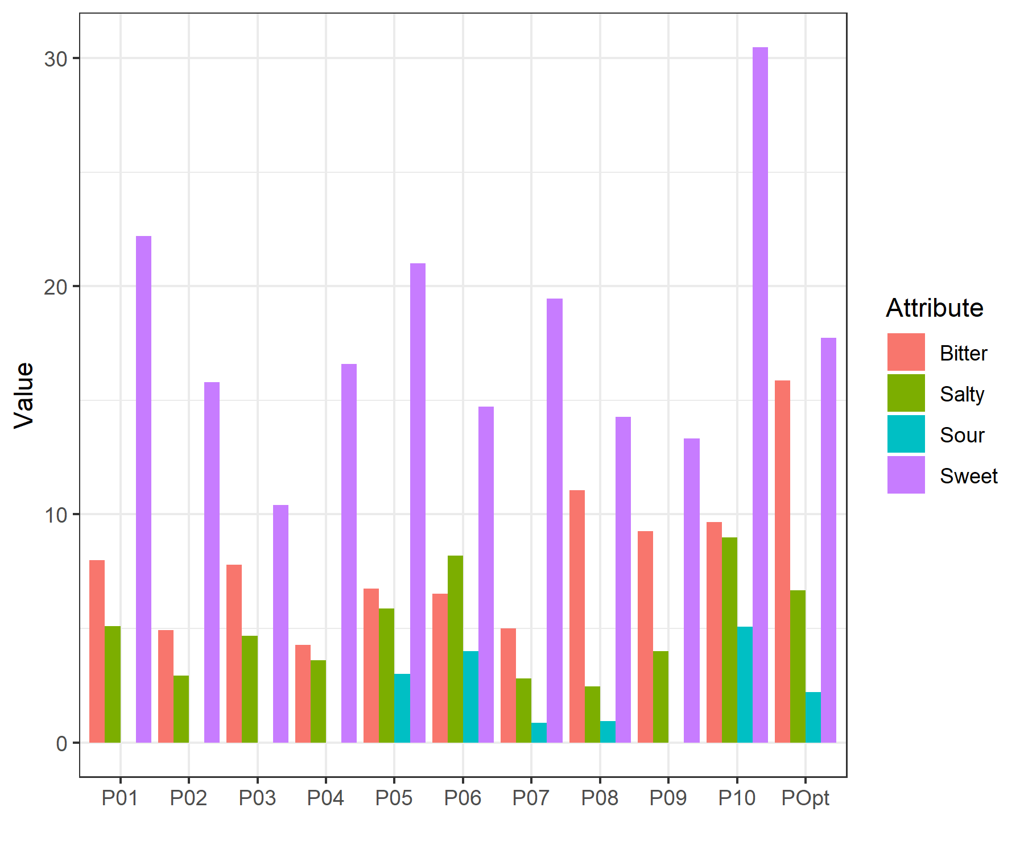

Figure : My first figure.

# Conclusion

# Table of Contents